**ADHD and/or Autism Initial Screening Pack**

If you are aged 18 or over and think you may have Attention Deficit Hyperactivity Disorder (ADHD) or Autism, also referred to as Autistic Spectrum Disorder (ASD), and want a referral for a diagnostic assessment for either, then please follow the below instructions with regards to an initial screening for this.

The below details are for adults aged 18 or over. If you are under 18 and are under a mental health team, such as CAMHS, then start by speaking with them about it, or book an appointment with your GP to discuss your symptoms. If you think your child may have ADHD or Autism, then you could also speak to your child’s SENCO lead in school, who could support and advise you on the appropriate referral route for your child.

Please be advised that for both ADHD and Autism (collectively referred to as Neurodiverse Conditions), your symptoms must have been present since childhood, and must affect your day to day functioning in some way. Please also be aware that both conditions can genetically run in families. If what you are experiencing can be explained by another mental health condition you will need to get in touch with your GP to see what else we can do to support you. In this case the referral will not be sent. If in doubt, please book in with our Mental Health Specialist Nurse, or a GP, to discuss this further.

**INSTRUCTIONS**

**Please complete the “About You” section and the relevant questionnaire/s in this pack for ADHD, Autism or both, along with the Problem Shared Suitability Criteria if you want to be referred to that service**

**Please then hand your forms into reception or post them back to the surgery**

**PLEASE NOTE**  
If you don't have access online, or you struggle to complete any of the above, then please talk to reception who can arrange an appointment with a clinician, for you to discuss your symptoms. Please note, there may be a wait for an appointment

**REFERRAL OPTIONS**You have a choice of where you can be referred to, if your screening meets the criteria for referral on for diagnostic assessment.

There is currently at least a 5 year wait to have a diagnostic assessment for ADHD/Autism with the local NHS Neurodevelopmental Service. Due to the demands on getting an assessment you can opt instead for a referral to ProblemShared under the NHS Patients Right to Choose, who assess by video link.

If you would like to be referred to ProblemShared, who have a significantly shorter waiting list, **please inform the surgery by noting this in the “About You” section of this information pack. Please also complete the ProblemShared Suitability Criteria Questionnaire, as we will need your answer to be able to refer you to this service.**

**PLEASE NOTE** :

IF YOU HAVE **COMPLEX MENTAL HEALTH NEEDS**, OR ARE **CURRENTLY AT RISK**, THEN WE CAN ONLY REFER YOU TO THE LOCAL SERVICE DUE TO SAFETY ISSUES WITH REFERRING TO OUT OF AREA SERVICES.

**ADHD MEDICATION**

If your assessment is for ADHD, and you are offered post assessment ADHD medication, then you will need to provide your personal measurements such as your height, weight, blood pressure, and pulse. You can get your blood pressure and pulse readings by using our self-service machine in the ground floor reception waiting area of Park Crescent Health Centre.

**CONTACT DETAILS FOR REFERRAL SERVICES**

If we have referred you to the local **Neurodevelopmental Service** for an assessment for ADHD/ASD their contact details are as follows:

Email: [ESNDS@sussexpartnership.nhs.uk](mailto:ESNDS@sussexpartnership.nhs.uk)

Telephone: 0300 3040096

If we have referred you to **ProblemShared** for an assessment their contact details are as follows

Website : https://www.problemshared.net/right-to-choose

Email: [enquiries@problemshared.net](mailto:enquiries@problemshared.net)

Telephone:020 3835 4727

**Useful Resources (please keep this page)**

**FOR ADHD**

<https://adhdaware.org.uk/> (advertises local ADHD support group)

<https://www.additudemag.com/> (has articles on emotional regulation and ADHD)

You may want to read the following information about ADHD from the Psychiatry-UK website:

<https://psychiatry-uk.com/adhd/>

Brighton and Hove Recovery College also offers free courses that you may find of benefit for help with emotional regulation :

https://www.southdown.org/services/recovery-college-brighton-hove/

You can also download several Apps such as Evernote or Coach.me that can help you keep track of your goals and daily reminders, such as eating or taking your medication.

**FOR AUTISM**

<https://assertbh.org.uk/>  (the local support service in Brighton for adults with Autism). Please note the Assert website mentions High Functioning Autism (HFA). If you don’t have a fully diagnosed learning disability, your Autism may sometimes be referred to as HFA, this was also previously termed Asperger’s Syndrome.

Additionally you may find the below websites helpful for information or meetings about Autism :

<https://www.autism.org.uk/advice-and-guidance/what-is-autism>

https://embrace-autism.com/autism-strengths-and-challenges/

[www.puzzlebored.co.uk/pages/neurodiversity](http://www.puzzlebored.co.uk/pages/neurodiversity)

[www.facebook.com/groups/adhocautistics](http://www.facebook.com/groups/adhocautistics)

Brighton and Hove Recovery College also offers free courses on autism that you may find of benefit:

https://www.southdown.org/services/recovery-college-brighton-hove/

You can also download Molehill Mountain, an App to help autistic people understand and self-manage their anxiety symptoms using cognitive behavioural therapy (CBT) techniques.

**About You**

Name……………………………………………………….

Date of birth………………………………………………..

Mobile number…………………………………………….

Email Address……………………………………………..

**Service you would like to be referred to (please tick one only):**

Local Neurodevelopmental Service -

Problem Shared Service -

Other Service - ………………………………………………………………………..

**PLEASE NOTE :**

**If no service is selected you will be referred to the local service which has a 5+ year wait. If you have selected ProblemShared please ensure you complete the exclusion criteria on the next page. If you have not answered this we will not be able to refer you.**

Do you have any existing mental health conditions?

.......................................................................................................................................

.......................................................................................................................................

.......................................................................................................................................

**If you need help with any of the above existing mental health conditions, then please book a 30 minute review with our Mental Health Specialist at the surgery, before completing these forms.**

Did you experience ADHD/AUTISM symptoms as a child?

Yes No

**PROBLEM SHARED SUITABILITY CRITERIA:**

**You or your child are not suitable for an online assessment with ProblemShared at this time if any of the following statements apply to you:**

* You are non-verbal and/or selectively mute
* You are unable to communicate at conversational level in English
* You have a diagnosis of global development delay or an intellectual disability (IQ below 70)
* You have a significant visual or hearing impairment which means that you/your child are unable to access online assessments
* You are currently psychotic or have recently experienced a psychotic episode (within 3 months)
* You are currently deemed to pose a risk to yourself or others and are not under care co-ordination with the local CMHT
* You are currently receiving treatment for an active eating disorder, or have been discharged within the last 6 months from a specialist eating disorder clinic
* You are currently receiving active medical treatment for drugs or alcohol addiction
* You have had a head injury or brain surgery or have a neurological condition which has left you with significant cognitive impairments
* You have previously been assessed by the NHS and are seeking a second opinion assessment
* You are currently serving a prison sentence, or are on temporary release
* You are undergoing a safeguarding investigation and cannot be seen until it has been concluded
* You are currently detained in a hospital under the Mental Health Act 1983, or under a community treatment order
* You currently serve in the armed forces
* You do not have access to a laptop or computer (please note that a tablet which is at least 10” in size and can be propped up to be used hands-free can also be used to access our service, but handheld devices such as mobile phones cannot)
* You do not have access to an internet connection in a private place
* You are not willing to conduct the assessment with your camera turned on for the duration of the assessment

Do you declare that you have read the suitability criteria and that you are suitable for our service?

Yes No

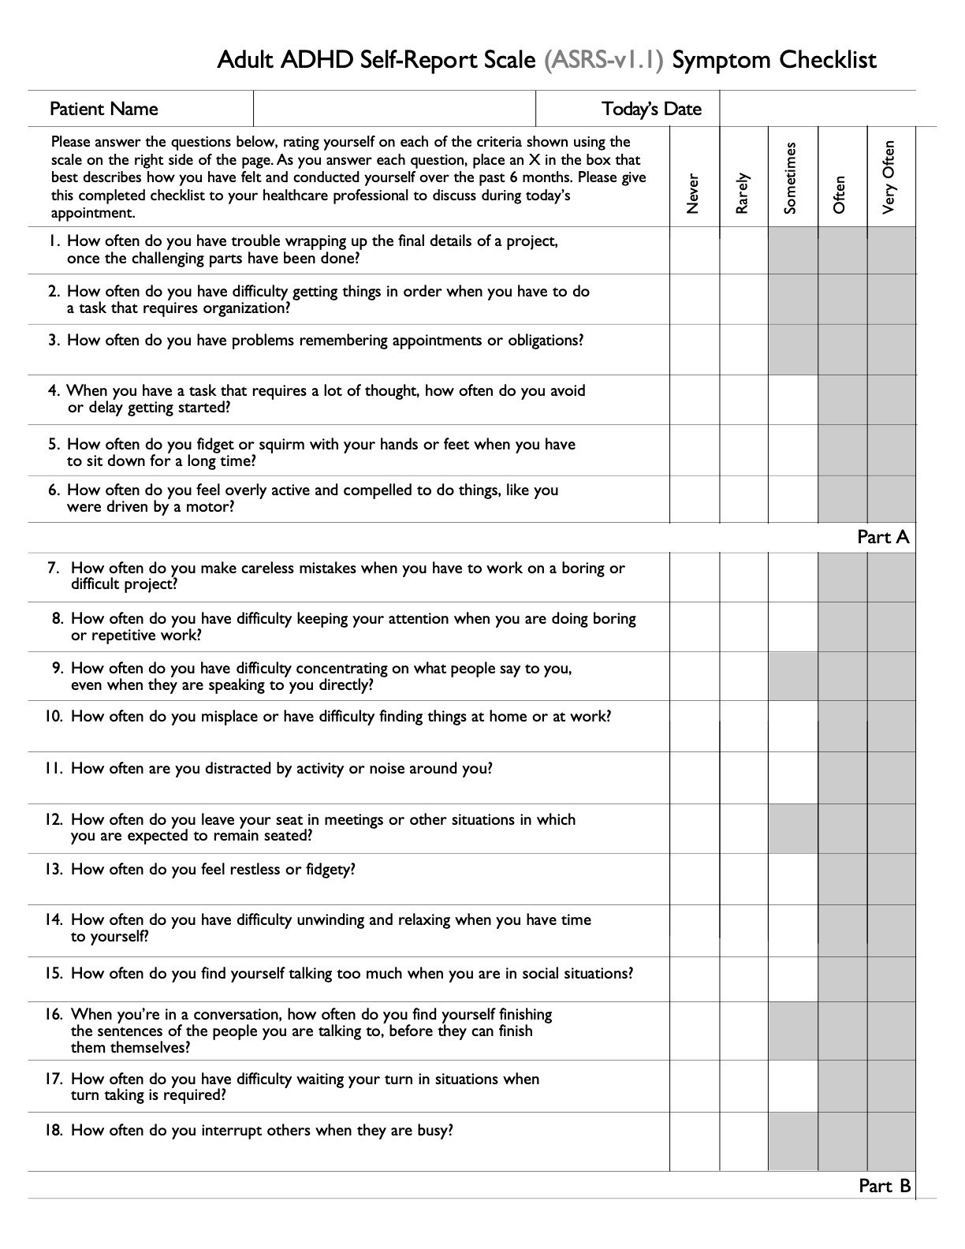

Autism Questionnaire AQ-50 Score:

1. Fill out the form below

2. Input your questions on the computer at : [https://psychology-tools.com/test/autism-spectrum-](https://gbr01.safelinks.protection.outlook.com/?url=https%3A%2F%2Fpsychology-tools.com%2Ftest%2Fautism-spectrum-quotient&data=05%7C02%7Ckerry.round%40nhs.net%7C27099dc858d346bbf3da08dcb1eece15%7C37c354b285b047f5b22207b48d774ee3%7C0%7C0%7C638580886414746500%7CUnknown%7CTWFpbGZsb3d8eyJWIjoiMC4wLjAwMDAiLCJQIjoiV2luMzIiLCJBTiI6Ik1haWwiLCJXVCI6Mn0%3D%7C0%7C%7C%7C&sdata=TBOJiUA0E8KQ56ioPdwa%2FkBivKeJhDih%2FIkKKFDF02M%3D&reserved=0)[quotient](https://gbr01.safelinks.protection.outlook.com/?url=https%3A%2F%2Fpsychology-tools.com%2Ftest%2Fautism-spectrum-quotient&data=05%7C02%7Ckerry.round%40nhs.net%7C27099dc858d346bbf3da08dcb1eece15%7C37c354b285b047f5b22207b48d774ee3%7C0%7C0%7C638580886414759199%7CUnknown%7CTWFpbGZsb3d8eyJWIjoiMC4wLjAwMDAiLCJQIjoiV2luMzIiLCJBTiI6Ik1haWwiLCJXVCI6Mn0%3D%7C0%7C%7C%7C&sdata=YujOBZaxZnnjOaShy%2BWLHg76eCyfbTl8UmtMTEaYLyg%3D&reserved=0)  or by clicking link

3. Score your form online

4. Write your score on the top of this form

N.B. if you have a printer you can do it all on the website then print your completed form with your score

|  |  |  |  |  |
| --- | --- | --- | --- | --- |
|  | Definitely  Agree | Slightly  Agree | Slightly Disagree | Definitely Disagree |
| 1. I prefer to do things with others rather than on my own. |  |  |  |  |
| 2. I prefer to do things the same way over and over again. |  |  |  |  |
| 3. If I try to imagine something, I find it very easy to create a picture in my mind. |  |  |  |  |
| 4. I frequently get so strongly absorbed in ones things that I lose sight of other things. |  |  |  |  |
| 5. I often notice small sounds when others do not. |  |  |  |  |
| 6. I usually notice car number plates or similar strings of information. |  |  |  |  |
| 7. Other people frequently tell me that what I’ve said is impolite, even though I think it is polite. |  |  |  |  |
| 8. When I’m reading a story, I can easily imagine what the characters might look like. |  |  |  |  |
| 9. I am fascinated by dates. |  |  |  |  |
| 10. In a social group, I can easily keep track of several different people’s conversations. |  |  |  |  |
| 11. I find social situations easy. |  |  |  |  |
| 12. I tend to notice details that others do not. |  |  |  |  |
| 13. I would rather go to a library that to a party. |  |  |  |  |
| 14. I find making up stories easy. |  |  |  |  |
| 15. I find myself drawn more strongly to people than to things. |  |  |  |  |
| 16. I tend to have very strong interests, which I get upset about if I can’t pursue. |  |  |  |  |
| 17. I enjoy social chit chat. |  |  |  |  |
| 18. When I talk, it isn’t always easy for others to get a word in edgewise. |  |  |  |  |
| 19. I am fascinated by numbers |  |  |  |  |
| 20. When I’m reading a story, I find it difficult to work out the characters intentions. |  |  |  |  |
| 21. I don’t particularly enjoy reading fiction. |  |  |  |  |
| 22. I find it hard to make new friends. |  |  |  |  |
| 23. I notice patterns in things all the time. |  |  |  |  |
| 24. I would rather go to the theatre than to a museum. |  |  |  |  |
| 25. It does not upset me if my daily routine is disturbed. |  |  |  |  |
| 26. I frequently find that I don’t know how to keep a conversation going. |  |  |  |  |
| 27. I find it easy to “read between the lines” when someone is talking to me. |  |  |  |  |
| 28. I usually concentrate more on the whole picture rather than on the small details. |  |  |  |  |
| 29. I am not very good at remembering phone numbers. |  |  |  |  |
| 30. I don’t usually notice small changes in a situation or a person’s appearance. |  |  |  |  |
| 31.I know how to tell if someone listening to me is getting bored. |  |  |  |  |
| 32. I find it easy to do more than one thing at once. |  |  |  |  |
| 33. When I talk on the phone I’m not sure when it’s my turn to speak. |  |  |  |  |
| 34. I enjoy doing things spontaneously. |  |  |  |  |
| 35. I am often the last to understand the point of a joke. |  |  |  |  |
| 36. I find it easy to work out what someone is thinking or feeling just by looking at their face. |  |  |  |  |
| 37. If there is an interruption, I can switch back to what I was doing very quickly. |  |  |  |  |
| 38. I am good at social chit chat |  |  |  |  |
| 39. People often tell me that I keep going on and on about the same thing, |  |  |  |  |
| 40. When I was young, I used to enjoy playing games involving pretending with other children |  |  |  |  |
| 41. I like to collect information about categories of things (e.g. types of cars, birds, trains, plants) |  |  |  |  |
| 42. I find it difficult to imagine what it would be like to be someone else. |  |  |  |  |
| 43. I like to carefully plan any activities I participate in |  |  |  |  |
| 44. I enjoy social occasions |  |  |  |  |
| 45. I find it difficult to work out people’s intentions |  |  |  |  |
| 46. New situations make me anxious |  |  |  |  |
| 47. I enjoy meeting new people |  |  |  |  |
| 48. I am a good diplomat |  |  |  |  |
| 49. I am not very good at remembering people’s date of birth. |  |  |  |  |
| 50. I find it very easy to play games with children than involve pretending. |  |  |  |  |